Commands Query Responsibility Segregation
Tuesday, April 14, 2020
9:54 AM

Clean Code With Entity Framework Core
EF Core is lightweight, extensible, open source and cross-platform version of EF data access technology.
ORM - Object Relational Mapper
EF is used to maintain the relationship between the different table/class.
DBContext: The most important class in EF
Interface to data via DBSet
Provides a Unit of Work, Tracks Changes
Sorts out relationships between Added, Modified, Unchanged Entities when you save
Important to manage lifecycle of DBContext

DBContext.Update(obj): Update typically will not be used, cause the object get from context is being tracked, the update will be useful when the DBContect that used to query the object has been closed, and it requires to update all modifications in the object to the database. It will mark the object dirty, and check any property even the foreign key in the object that whether modified or not.
Eg. Context.Update(obj); Context.SaveChanges();

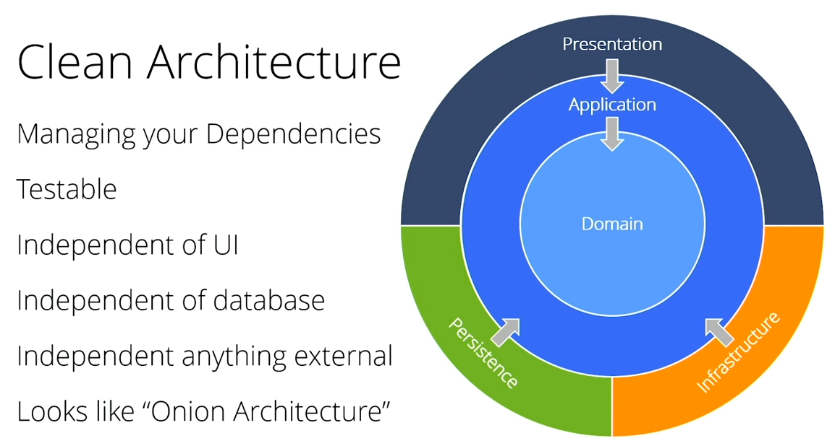
Domain : Domain Models/Entity Models
Infrastructure: Services with Interfaces
Persistence : Like repositories/DbSet related operations - Read data, write data, those are always immutable, what will change are services that will take use of that

Repository pattern is not necessary cause DbSet acts as a repository. You can you Repository pattern but not have to.
EF Code insulates code from database changes
DBContext acts as a unit of work
DBSet acts as a repository
EF Core has features for unit testing without repositories
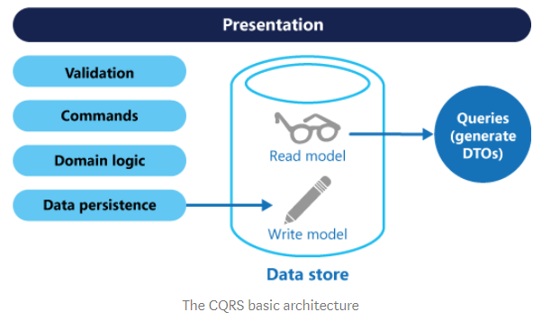
CQRS: Command Query Responsibility Segregation - Split commands of writes from reads
Typically you want the reads to be as quick as possible, and writes as correct as possible
Single Responsibility Principle
Easy to add new features, just add a new query or command
Easy to maintain, changes only affect one command or query
Can be used with repositories

Revisiting CQRS:
Event sourcing - For really high throughput database
Separate data stores for reads and writes
Clearly separated command and query operations
Separate processes for reads and writes

Event Sourcing:
The fundamental idea of Event Sourcing is that of ensuring every change to the state of an application is captured in an event object, and that these event objects are themselves stored in the sequence they were applied for the same lifetime as the application state itself.<https://martinfowler.com/eaaDev/EventSourcing.html>
Event sourcing is a great way to atomically update state and publish events. The traditional way to persist an entity is to save its current state. Event sourcing uses a radically different, event-centric approach to persistence. A business object is persisted by storing a sequence of state changing events. Whenever an object’s state changes, a new event is appended to the sequence of events. Since that is one operation it is inherently atomic. A entity’s current state is reconstructed by replaying its events. <https://eventuate.io/whyeventsourcing.html>

MediatR + CQRS : MediatR is a great library, which allows implementation command/queries and handlers loosely coupled.
https://medium.com/@ducmeit/net-core-using-cqrs-pattern-with-mediatr-part-1-55557e90931b
Define commands and queries as requests
Application layer is just a series of request/response objects
Ability to attach additional behavior before and/or after each request, eg. logging, validation, caching, authorization and so on

Using MediatR:
"Commands should be task-based, rather than data-centric. (“Book hotel room,” not “set ReservationStatus to Reserved.”) Commands may be placed on a queue for asynchronous processing, rather than being processed synchronously.
Queries never modify the database. A query returns a DTO that does not encapsulate any domain knowledge."
All requests should implement IRequest interface, which will be used by the handler to process request.
All handlers should implement IRequestHandler interface. This interface depends on two params, first -> Request, second ->response.
Controller: inject mediator and send the query.

CQRS +EF Core:
Read Operations:
Select/Project into View Models
No Change Tracking: save time of query
Write Operations:
Work with entities
DbContext/Unit of Work

Tips: Use IQuery and applies attached to the IQuery to get objects. It will do the query in SQl and load the models to viewmodel, we just load those that we need.
Eg. var efQuery = _contect.Set<Customer>().Where(c=>true);
efQuery = ApplyFilters(efQuery, request);
efQuery = ApplyPaging(efQuery, request);
return await SimpleSelect(efQuery);
// Here we use new, cause we don't have the mapping relation between Database and Models
Private async Task<Ienumerable<CustomerOrdersModel>> SimpleSelect(Iquery<Customer> efQuery)
{ return await efQuery.Select(c=>new CustomerOrdersModel())
{ Name = c.CompanyName,
CustomerId = c.CustomerId,
CountOrders = c.Orders.Count(),
Orders = c.Orders.Select(o => new CustomerOrderModel()
{
OrderId = o.Id,
EmployeeId = o.EmployeeId,
EmployeeName = o.Employee !=null ? o.Employee.FirstName + " " + o.Employee.LastName :string.Empty,
OrderDate = o.OrderDate
})
}).ToListAsync();
}

Or we can use AutoMappper to replace the block of code, it'll save time but in some cases will be hard to debug when problems occurs
Private async Task<Ienumerable<CustomerOrdersModel>> AutoMapper(Iqueryable<Customer> eQuery)
{
Return await efQuery.ProjectTo<CustomerOrdersModel>(MapperConfig).ToListAsync();
}

EF Core and Ilogger<>
Easy to get logs out of Entity Framework
Integrates well with Serilog, SEQ, Application Insights
Measure the number of SQL statements executed per command/request
Use Query Tags to identify the code that invoked a query

